**Configure MODBUS TCP for Smart Meter**

Taki Guan

# Version History

|  |  |  |  |
| --- | --- | --- | --- |
| Version | Author | Date | Changes |
| 1.0 | Taki Guan | 2019-4-18 | Create Document |
|  |  |  |  |
|  |  |  |  |
|  |  |  |  |
|  |  |  |  |
|  |  |  |  |

Contents

Version History 1

Purpose 1

Procedure 2

Architecture 7

Reference Link 7

# Purpose

This is first time to use Modbus TCP DI server to communicate with the smart meter we use to capture power of T2BH0208.

DI configuration and OPC client configuration are included in this document.

# Procedure

Download [Setup-MBTCP-OI] from AVEVA website and install it in one of AOS server. Here we installed in [SWGCSXTBAOS3].



Expand [Operation Integration Server Manager] to make sure Modbus TCP OI server is installed correctly.

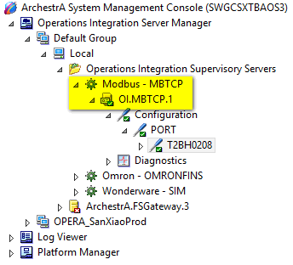

We can right click on the [Configuration] port to add a [ModbusPLC] connection. Remember the default port we use is 502.

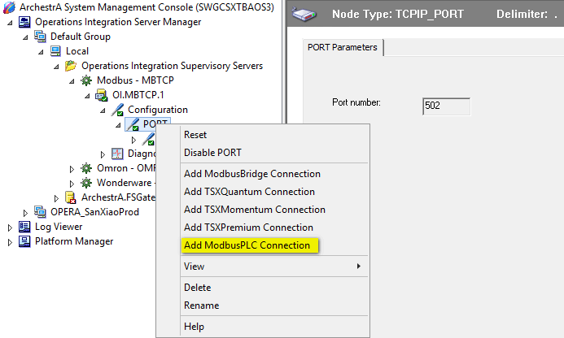

After creating the [ModbusPLC] connection, we should modify the IP address to exact the Smart meter IP. Remember we need to change [Register size] digits to the same digits the smart meter use. The [Register Order] should be the same as smart meter also.

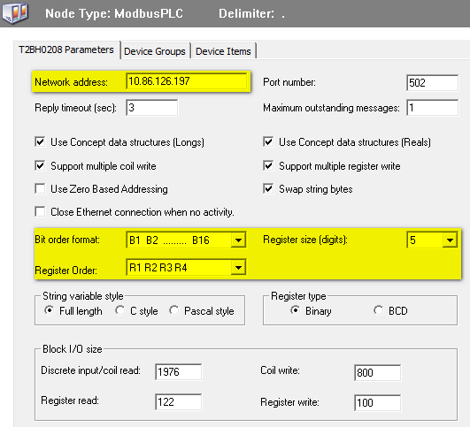

After the configuration, we should restart OI server to make the configuration take effect. Then we use [ModScan] tool to help to find the exact tag of the smart meter.

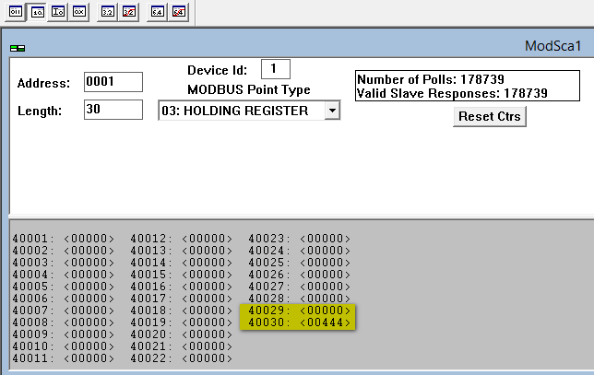

We can see the exact value stored in [40030] is 444, then we read it out. The result is exactly the same.



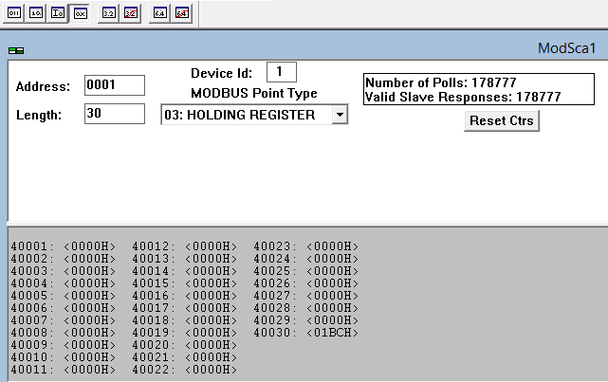

The issue we meet is the data in smart meter is stored as hex value in both [40029] and [40030]. The exact degree value stored in smart meter is [000001BC] HEX. But we read [40029] and [40030] out is 0 and 444 in

# Architecture

# Reference Link